WaterMe

Use-Case Specification: See Smileys

Version 1.0

Revision History

|  |  |  |  |
| --- | --- | --- | --- |
| **Date** | **Version** | **Description** | **Author** |
| 04/Jun/2017 | 1.0 | First version | Paul Giesa |
|  |  |  |  |
|  |  |  |  |
|  |  |  |  |

Table of Contents

1. Use-Case Name 4

1.1 Brief Description 4

2. Flow of Events 4

2.1 Basic Flow 4

3. Espresso test 4

4. Preconditions 4

5. Postconditions 4

Use-Case Specification: See Smileys

# Use-Case Name

## Brief Description

The Extension board comes with a small display which is used to display different smiley depending on the current humidity.

# Flow of Events

## Basic Flow

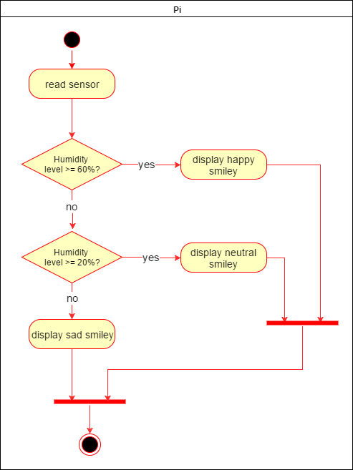

# Espresso test

# Preconditions

(n/a)

# Postconditions

The display shows one of three possible smileys